REPORT

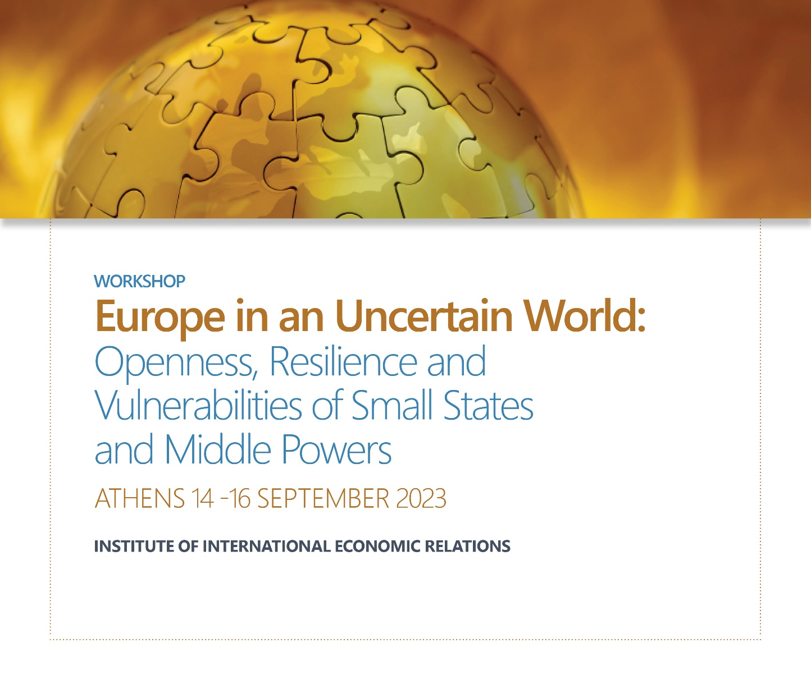
Sponsors:

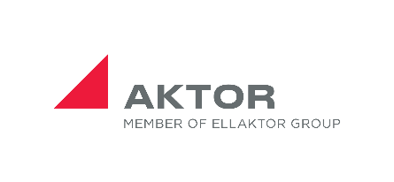

The workshop organised by the Institute of International Economic Relations (IIER) (Research Programme on the Theory and Practice of International Relations) in collaboration with the following institutions:

- Neapolis University Pafos, Cyprus
- Institute for European Studies, University of Malta
- Department of Political Science and International Relations,
University of the Peloponnese, Greece
- Department of International and European Studies,
University of Macedonia, Greece

In the opening session: Europe at a Crossroads, there were three key note speeches by:

- Prof. Frank Barry, MRIA, Chair of the International Business and Economic Development Department of the Trinity Business School, Trinity College Dublin, Dublin: Reflections on Ireland's Journey from Agricultural Satellite of the UK to Modern European Economy.
- Prof.Alfred Tovias, Emeritus, Department of International Relations of the Hebrew University of Jerusalem, Jerusalem, EU Foreign Policy on the Israeli- Palestinian Conflict: A Re-evaluation.
- Mr. Dimitrios Kourkoulas, Former Deputy Minister of Foreign Affairs of Greece, Responsible for European Affairs and Economic Diplomacy. The Role of Small and Micro States in the EU: Resilience and Vulnerabilities.

Summary of the papers

1. Quo Vadis Europa? New Role and an Upgraded Mission for the New Era Ahead
Spyridon L. Litsas (Department of International and European Studies University of Macedonia, Thessaloniki)
The paper discussed the concept of bipolar multilateralism, smart state and the conceptual emergence of a sui generis international balance of power. Within this specific context, the role of the EU was analyzed, mainly from a political point of view. The European institutional contextual elements were also discussed under the influence of bipolar multilateralism, reintroducing a classic question: “Quo Vadis Europa?” From a methodological point of view, the analysis used neo-realist tools, in order to identify if and under which conditions a new role for the EU and the transatlantic partnership is possible that could lead to new grounds of political and economic maturity in the Western World.

2. The Shifting Continental Security Architecture: Ukraine-Centred Multilateral Security Alignments in Europe

Konstantinas Andrijauskas (Institute of International Relations and Political Science, Vilnius University, Vilnius)

Based on the framework of ‘alignment’ and drawing upon small state studies and the conceptual framework of defensive realism, the paper presented a comparative analysis between the 2020 Lublin Triangle initiative (Lithuania, Poland and Ukraine) and the 2022 Trilateral Pact (United Kingdom, Poland and Ukraine), focusing on all of the protagonists’ main interests and goals. While the main rationale for Ukraine is rather straightforward, other partners are indeed characterised by status-increasing logic that is curiously common to a small state (Lithuania), a middle power (Poland) and a great power (United Kingdom).

3. Oscillating Between Security-Seeking and Status-Seeking? Turkey’s Power Activism

Kyriakos Mikelis (Department of International and European Studies, University of Macedonia, Thessaloniki)

The paper discussed Turkey’s powerhood which has inspired various arguments regarding the conceptualization and emergence of the country as a small power or a middle power, or, nowadays, an aspiring great power regionally and internationally. In this context, emphasis was given to the oscillation between the pursuit of security and the pursuit of status and to the relevance of both material factors and intersubjective ones. Indeed, issues of identity construction have emerged as a catalyst in the sense that the country’s ongoing search for identity serves as an important indicator of the degree of affecting the status quo and of the country’s resilience and vulnerabilities.

4. Shelter-Seeking Strategy of Sweden and Finland: From the Beginning of the Cold War to NATO Membership

Baldur Thόrhallsson (Research Director of the Centre for Small State Studies, University of Iceland, Reykjavik)

The aim of the paper was to examine whether shelter theory can shed a new light on their foreign policy choices to join NATO and test whether the theory is applicable to study small states that have traditionally adopted neutrality/non-alignment. The findings indicate that shelter theory captures an untold story that lays behind Sweden´s and Finland’s close relations with Western powers, that is their political, economic and societal shelter-seeking. Nevertheless, these cases indicate that shelter theory needs to take a closer look at four features regarding relations between small and large states: how an agressive neighbour can restrict a small state‘s foreign policy choices; how economic and societal shelter relations may precede political shelter relations (or vice versa); the role of critical junctures in the dvelopment of their relations; and, finally, whether and under what condictions a history of cooperation might be transitioned into full-fledged shelter.

5. The 2008 Economic Crisis in Cyprus: A (De)Europeanization or a Shelter-Seeking Strategy?

Charalampos Tsardandis, (Director, Institute of International Economic Relations (IIER), Athens)

The paper, by analysing the 2008 economic crisis in Cyprus, attempted to answer the following questions: First, to what extent the foreign policy of Cyprus has been conducted during the crisis within or via the European Union? Second, how the economic crisis has impacted upon the europeanisation/ de-europeanisation of Cyprus’ foreign policy, and to what extent did Cyprus follow a shelter seeking strategy? Third, is there any indication that Cyprus after the end of the crisis was able to overcome the limits of its small size by maximizing the opportunities presented by its membership in the CFSP?

6. Small States as Agents of Change and Innovation in the European Space: The Cases of Ireland, Greece, Cyprus and Iceland

Effie Charalampaki, Kostas Pechynakis, Nefeli Athanasaki, Giorgos Fragkos, Valasis Simitsis (Research Program on the Theory and Practice of International Relations, Institute of International Economic Relations, Athens)

The paper analysed what each one of the four states can learn from the governance successes and failures of the other three states despite individual particularities. The focus of the paper was on developing a policy model by incorporating the methodological tools of innovation cooperation and the literature on the entrepreneurial state, that could be potentially utilized by other microstates.

7. The Parliamentary Diplomacy of Small European States: Ordained to Remain Peripheral?
Roderick Pace (Institute for European Studies, University of Malta, Valletta)
The paper explored how much we really know about small European parliaments; their role in parliamentary diplomacy; and their contribution to it. The paper begins by a very brief discussion on a select group of small-state parliaments and their engagement in parliamentary diplomacy. Small-state parliaments have a history that, in some cases, stretches back several centuries. However, the main focus of this paper is the Maltese parliament that was established in 1921 during the colonial era, which became sovereign in 1964. The Maltese parliament has been influenced by the Westminster system. Its activities in international affairs are compared to that of other commonwealth small-state parliaments. One of the constraining factors on small-state parliaments’ diplomatic activity is their small size and limited resources. In Malta’s case, this problem is compounded by the fact that it is a ‘traditional’ parliament in the true meaning of the term since its members of parliament are part-timers.

8. A Panoramic View of the Parliamentary Diplomacy of European Microstates: The Cases of Andorra, Monaco and San Marino

Jordi Xuclà, (Department of Communications and International Relations, University Ramon Llull, Barcelona)

The paper analyzed the parliamentary diplomacy of three European micro-states, Andorra, Monaco and San Marino, focusing on: a) in which international organizations the parliaments of the three states have presence; b) the key topics that each country has chosen to highlight in parliamentary diplomacy; c) the composition of the parliamentary delegations of the three micro-states in front of international organizations; d) the privileged parliamentary diplomacy that each microstate maintains with its neighbouring countries. That is to say: Andorra with France and Spain; Monaco with France; and San Marino with Italy. Finally, the informal forms of parliamentary diplomacy that the parliaments of the three microstates maintain with the European Parliament were analysed.

9. The Parliamentary Diplomacy of a Small State in the Context of the Russian Invasion of Ukraine: The Case of Luxembourg

Laura Gil-Besada (Chaire de Recherche en Etudes Parlementaires, Université du Luxembourg, Luxembourg)

The paper examined the reactions of Luxembourg's Parliament (“Chamber of Deputies”) to Russia's war on Ukraine since 22 February 2022, without neglecting earlier direct and indirect attacks, such as the ones in Crimea and Donbass in 2014. The paper illustrated and explained the existence of a general consensus among political parties on diverse war-related issues, while not overlooking potential or actual divergent opinions on topics such as arms supply deliveries. Methodologically, the paper draws upon a variety of primary sources, including parliamentary debates, questions, resolutions and voting records, as well as overseas activities, such as visits by Luxembourg parliamentarians to Ukraine.

10. Turkey’s Middle Power Pendulum: “Middle Corridor’s” Project Coupling with China’s “One Belt-One Road” Initiative in Eurasia

Thrassy N. Marketos (Department of Economics and Technology, University of the Peloponnese, Tripoli)

The paper explored Turkey’s vision for a multi-polar world with it as one of the poles. Turkey has seen the ‘Middle Corridor’ as a way to not only build stronger economic ties to Central Asia, but also improve its strategic position. Although China may currently share a “no limit” partnership with Russia, and regulated rivalries within the scope of the Shanghai Cooperation Organization in the 2000’s, the longevity of that partnership is not guaranteed. Turkey has hoped to leveraging its common linguistic roots with Turkic-speaking countries in the region and offering them a trade outlet that is an attractive alternative to those of Iran or Russia, Turkey’s longtime rivals. The analysis -based on the neo-realist school of International Relations- seeks to demonstrate that for Ankara the “Middle Corridor” project’s combination goal to China’s Belt & Road initiative reflects Turkey’s geostrategic self-identification in the 21st century.

11. Turkey’s Behaviour as a Middle Power: Navigating the EU-China Competition through Transactionalism
Edoardo Lavezzo (Department of Politics, Derwent College, University of York, York/Heslington)
Drawing from Neoclassical Realism (NCR), the paper examined the debate about middle powers’ foreign policy behaviour, by investigating if Turkey has changed its agency in the region while exercising a transactional foreign policy towards the EU and China. At first, the paper underlined that the international system and the regional changes caused by power vacuum and competition have affected the behavioural approach of Turkish foreign policy towards the EU and China. In the second part, the paper analysed that adoption of Neo-Ottoman ideology as the new ideational factor behind Turkish foreign policy. Finally, the paper explained where transactional behaviour of Turkish foreign policy has been manifested towards the EU and China, and if through such approach, Turkey has manifested a regional power agency.
12.Small States and the E.U. Policy Making Process: The Case of the 2015 Refugee Crisis

Korina Asteriou (Department of International and European Studies,
University of Macedonia, Thessaloniki)

The paper explored of how small EU member-states can have a more defining role in the EU policy making process, especially for matters that concern them on a large scale, so that the policy implications would have effective results in the integration of the refugees, in the inner-markets and, most of all, in social progress.The refugee crisis hitting Europe, and, in particular, many small European states, such as Greece, has been a great example of how policy-implementing would be facilitated and become more effective if the smaller states had been part of the policy-making process. In the case of the refugee crisis, a large number of particular issues arose among the small European states, since those states’ financial capabilities and administrative protocols were deficient compared to the overwhelming needs that arose.

13.At the Crossroads of Realism and Idealism: The States of the Scandinavian Peninsula and the Inevitable End of a Journey on Two Boats

Georgios K. Papadimitriou (Department of International and European Studies, University of Macedonia, Thessaloniki)

The paper focused on the states of the Scandinavian peninsula aiming to (a) demonstrate the almost identical and unconventional grand strategic stance these actors have adopted, at least since the late 2000's, which though it rests on a classical realistic foundation it has been dominated by predominantly idealistic predispositions; and, (b) emphasize the need for a more realistic approach. The article revealed that the administrations of these actors, in demonstration of their thorough understanding of the founding principles of the "realism of human nature", have been successfully enhancing the ontological soundness of their states primarily from within via focusing on satisfying the primary structural elements of their states, i.e., human beings and their innate need to live and prosperhe The article suggested that there is enough room to move further towards this realistic direction sacrificing part of the so far attained prosperity and it even attempted to quantify the size of this buffer zone via establishing an empirical prosperity threshold value that serves as a socio-political stability/instability indicator

14.Confronting the Future: Cultivating Small State Resilience Through Strategic Foresight

Hillary Briffa (Department of War Studies, King's College, London)

Whilst small states are often shown to be adept at adapting and responding to crisis, this paper went a step further and set out to understand how small states can better think about and prepare for a more conflictual future. Through a case study of Estonia, it examined the kind of national security architecture, processes and training opportunities, and foresight methods that can be adopted by small states to develop greater resilience towards uncertain futures, and to engender greater security for small NATO allies in the context of Anglo-American visions for the future (including balancing alliances and regional security solutions with safeguarding strategic autonomy). In doing so, it provided practical recommendations to enable such small states to become more proactive agents, rather than subjects, in confronting future change.

15.Small States and Middle Power Cooperation? The Comparative Analysis of Latvia’s, Lithuania’s and Poland’s Policies Towards Belarus after 2020

Mariusz Antonowicz (Ph.D., Institute of International Relations and Political Science, Vilnius University, Vilnius)

The main goal of the paper was to compare Latvia’s, Lithuania’s and Poland’s foreign policies towards Belarus after the 2020 presidential election and examined how these countries attempted to coordinate their actions towards Belarus. To answer this question, it employed Andrew Moravcsik’s liberal IR theory. Since Latvia and Lithuania are treated as small states and Poland as a middle power hence, these countries’ potential cooperation in reaction to Belarus’s political crisis can be treated as an instance of small states and middle power interaction The paper shed more light on small states’ willingness to cooperate with middle powers and the conditions under which this happens.

16.The Evolution of Society’s Perception of the Concept of Security in the Period 2013-2022 and the Influence on the Three Seas Initiative: The Case Studies of Romania, Poland and the Baltic states

Andreea-Amalia Stănică (National University of Political Studies and Public Administration (SNSPA), Bucharest)
The basic hypothesis of the study focused on the issue of the constantly changing geopolitical environment, namely the existing tensions at the regional level that generate changes in the population’s perception of the concept of security, an aspect that provides the opportunity to transform the Three Seas Initiative (3SI) into a viable regional initiative. From a methodological point of view, quantitative methodology was used, presenting an analysis of data provided by the security barometers of Romania, Poland and the Baltic states in order to identify the evolution of the population’s perception of the concept of security during the last seven years. In order to have a relevant result, the time period analyzed was framed between two key moments, starting from the period before the annexation of Crimea until the outbreak of the Russia-Ukraine war. Through this approach, the aim was to identify the extent to which the strategic documents reflect the vision found at the societal level. The novelty element of the study came from the association of the phenomenon of the intensification of security concern as a factor that facilitated regional cooperation, respectively cooperation within the 3SI.

17. Minilateral Defense Cooperation in Europe as a Tool for Small States

Karolina Gawron-Tabor & Joanna Piechwiak-Lamparska (Ph.Ds, Nicolaus Copernicus University in Torun, Torun)

The aim of the paper was to analyze the minilateral cooperation formats in the field of defense and determine whether those formats are utilized by small states. First, the minilateral formats of defense cooperation in Europe were presented. Minilateral defense cooperation in Europe is exemplified by the following initiatives: the European Intervention Initiative, Joint Expeditionary Force, Nordic Defense Cooperation and the Visegrad Defense Cooperation. Minilateral defense cooperation has accelerated during the coronavirus pandemic (2020) and the Russian aggression against Ukraine (2022). Next, the participation and involvement of small European states in these respective formats were examined. An attempt was made to verify the hypothesis that minilateral formats are primarily utilized by small states as a tool of defense and foreign policy.

18. The Soft-Power Strategy as the Optimal Choice for Small States and Middle Powers in the New Phase of Globalization: The Role of a New Public Diplomacy

Nikolaos Vlahakis (Minister Plenipotentiary for Public Diplomacy, Embassy of Greece in Bucharest, Bucharest)

The paper underlined that small states and middle powers, despite transformations, remain still the basic actors in the international arena but a re-adaptation of national strategies, amid a number of challenges,like the transition from the concept of international society to the concept of international community and the consequent need for creating institutions of "world governance is required. Small states and middle powers, despite these transformations, remain still the basic actors in the international arena but a re-adaptation of national strategies, amid these challenges, is required For this purpose, the optimal choice is the development of a soft-power strategy based on values and a relevant state-rhetoric of building cooperation and synergies. The role of the New Public Diplomacy, with its definitions and tools, becomes more and more a strategic element for constructing a reliable positioning in this new global order.

19.Middle Powers and Inter-regionalism: The Case of MIKTA

Eleni-Maria Kalafati (Instructor of Economics and Negotiations, City Unity College, Athens, and Institute of International Economic Relations)

The paper examined MIKTA(Mexico, Indonesia, South Korea, Türkiye and Australia) , a grouping of middle-power countries, and its minilateral potential. The paper assessed MIKTA’s internal and external dimensions, on several analytical axes, namely the features of the group, the internal and the external facilitating factors, including the input and output legitimacy.
Overall, MIKTA has emerged as an important platform for promoting global cooperation and multilateralism, as well as for advancing the economic and political interests of its members. The group has demonstrated a commitment to open economies, human rights, and democracy, and has been actively engaged in promoting dialogue and collaboration among its members and with other countries and international organizations. As the world continues to face complex global challenges, the role of the MIKTA group in promoting international cooperation and collective solutions is likely to become even more important in the years to come.

20. Greece’s Foreign Policy Response towards the Blue Homeland Narrative: A Response from a Medium Power Facing Regional Revisionism

Fotini Bellou, (Department of International and European Studies, University of Macedonia, Thessaloniki)

For a number of scholars, the “Blue Homeland Narrative” is coming to function as a strategic compass for Turkey’s policy in the region. For others, it remains a temporary instrument of Ankara’s projection of power politics in the region. After unpacking the contents of the doctrine, the paper critically investigated the way in which the Blue Homeland narrative has culminated into becoming a regional doctrine defining Turkish foreign policy. Because of key revisionist claims, this analysis argued that, under its current form, it seriously challenges Greece’s status quo approach to its foreign and defence policy. Based on primary research material regarding the nature and character of the “Blue Homeland” doctrine, as it is presented by the Turkish government, the paper aimed at showing how compact this narrative appears and whether it offers opportunities for cooperation with neighbouring countries including Greece or it culminates further tensions to which Greece has started to address.

21. Parliamentary Diplomacy as a Key Factor to Conclude the Monitoring Process of the Council of Europe in Andorra and Monaco

Jordi Xuclà ( Universitat Ramon Llull, Barcelona)

The Parliamentary Assembly of the Council of Europe (PACE) has broad powers to assess progress in the reforms required in the States. For European micro-states, such as Andorra, Monaco, San Marino and Liechtenstein, their membership is key to the adoption of standards defined in the organization's Conventions. In the accession of Andorra and Monaco to the Council of Europe, the two states became full members with the conditionality of proceeding to face reforms to adjust their legal frameworks to the standards of the international organization. The paper focused on: a) a brief description of the functioning of the PACE Monitoring Committee; b) a description of the obligations that Andorra and Monaco acquired when they acceded to the Council of Europe; c) the study of the evaluation works of the reforms that made on Andorra and Monaco by the parliamentary rapporteurs for the two countries; and d) the study of the acts of parliamentary diplomacy carried out by the delegations of Andorra and Monaco to conclude the monitoring process.

22. From Identity to Prosperity: Revealing the Power of Cultural Diplomacy in Small States and Middles Powers –The Cases of Greece and Italy

Georgia Manolopoulou (Candidate, Department of Political Science and International Relations, University of the Peloponnese, Corinth)

The paper aimed at shedding light on how small states and middle powers can effectively utilize cultural diplomacy to enhance their national interests, international reputation, promote their unique national identity and stimulate economic growth. What role does cultural diplomacy play in shaping the identity and global influence of small states and middle powers? How does cultural diplomacy contribute to their economic prosperity and stability? This paper explored the significance and potential of cultural diplomacy as a soft-power tool for small states and middle powers in advancing their national interests by examining the case studies of Greece and Italy. Through initiatives like cultural centers, festivals, UNESCO sites, cultural industry, tourism and culinary diplomacy, both countries have effectively used their cultural common ground as a powerful tool.

23. Navigating an Uncertain World: The Role of Diplomacy and Foreign Policy in Small States and Middle Powers)

Aikaterini Patrikiou ( Athens University of Economics and Business, Athens)
This paper provided an in-depth examination of the role of small states and middle powers in diplomacy and foreign policy. It investigated the impact of slowbalization, the war in Ukraine, and the role of international organizations on their approach. T The analysis underscored the importance of small states and middle powers in shaping the global order, as they can significantly impact regional stability and security. Theoretical frameworks were employed, and case studies were analyzed to provide a better understanding of the various factors that influence the approach of small states and middle powers, such as geography, history, culture, economic factors, and political systems. In conclusion, this paper summarized its main findings and implications for the role of small states and middle powers in diplomacy and foreign policy. It recommended further research to expand on the topics discussed in this paper and to explore additional dimensions of the role of small states and middle powers in international relations.

