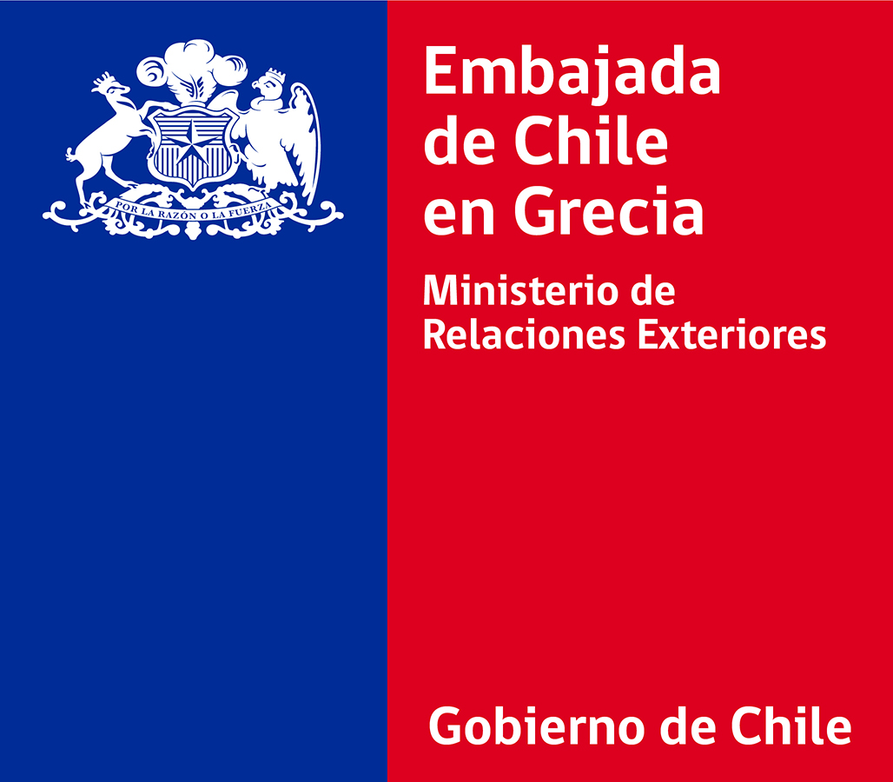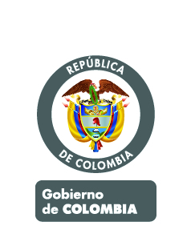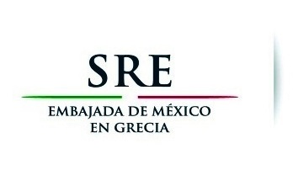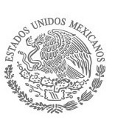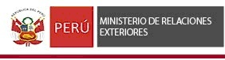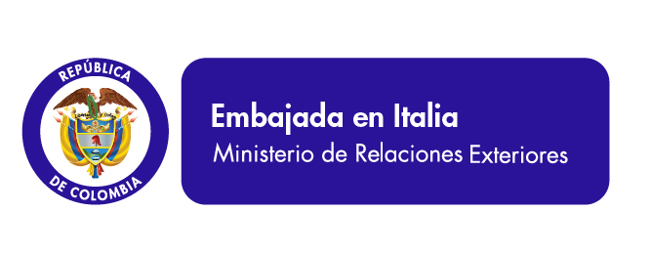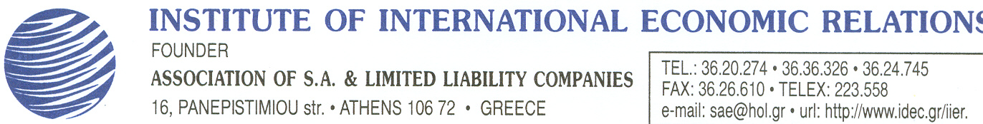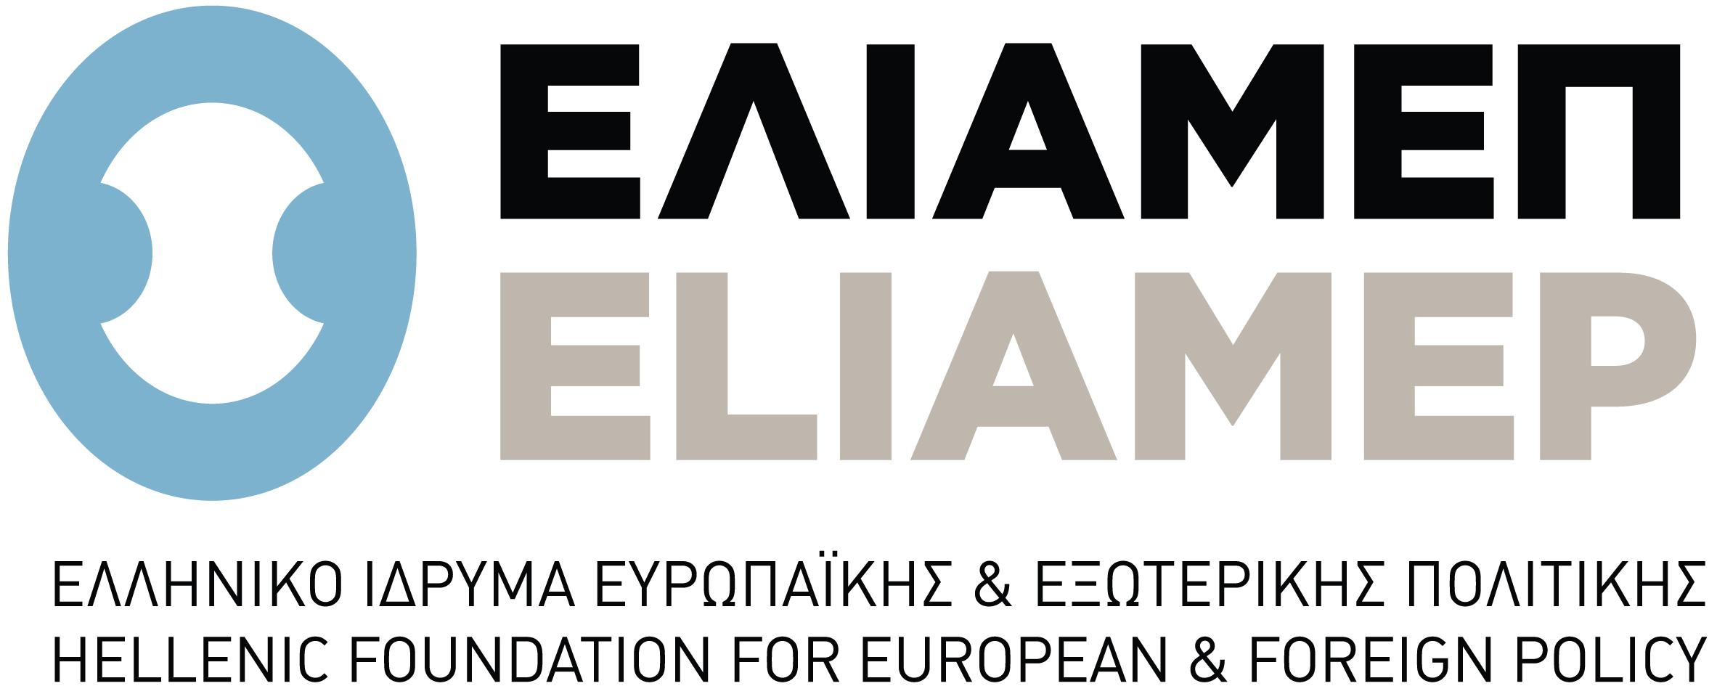

**REGISTRATION FORM**

**20 November 2014**

**CHILE -COLOMBIA - MEXICO - PERU**

**Auditorium "G. Kranidiotis"**

**Ministry of Foreign Affairs of the Hellenic Republic**

**Akadimias 1, Athens**

**Thursday, November 20th 2014, 10.45 a.m.**

**Working Language: English**

**Information: Embassy of Mexico, Tel. 210 729 47 80 ext. 4**

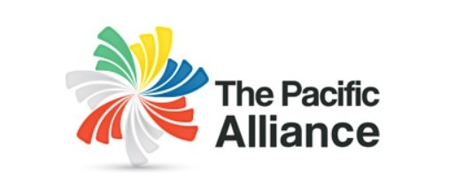

**http://alianzapacifico.net/**

**THE PACIFIC ALLIANCE:**

**OPPORTUNITIES IN LATIN AMERICA FOR GREEK ENTERPRISES**

**Name:**

**Surname:**

**Organisation's Name:**

**Job Title:**

**Email:**

**Phone:**

**Mobile:**

**Please, fill in and send the Application Form to:**

**Email: sae@hol.gr FAX: 210.36.26.610**